Urdu Q/A Portal

**Software Requirements Specification**

Version 1.0



**Group Id: F220253919**

**Supervisor Name : Usman Waheed**

**Revision History**

|  |  |  |  |
| --- | --- | --- | --- |
| **Date (dd/mm/yyyy)** | **Version** | **Description** | **Author** |
| 12-12-2022 | 1.0 | The Urdu Q/A portal will allow users to post questions in urdu and the registered users of application will answer the posted questions. The guest user able to see and search questions and the answers.  This SRS will provide the scope, functional requirements, non-functional rquirements and work flow of this project. This SRS will lead this project from start to final result. | bc210202333 |
|  |  |  |  |
|  |  |  |  |
|  |  |  |  |

**Table of Contents**

1. Scope (of the project)
2. Functional Requirements Non Functional requirements
3. Use Case Diagarm
4. Work Plan (Use MS Project to create Schedule/Work Plan)

**SRS Document**

Scope of Project:

In this modern era of technology a large number people of Pakistan use internet. People spend more time on social media platforms and many people post in urdu language. Many people only know urdu and they also type in urdu.

As we know Urdu is mother tongue of Pakistan and this web application will help and provide a flexible & easy platform to users to post their questions in urdu language, and the other users of application will answer the posted questions in urdu. The guest user can see the questions and their answers, and also find his/her question & answer. This type of application will promote Urdu language in Pakistan and will tend people to use & comminacte with others in urdu.

This web application will provide:

* Registered user can post question in urdu
* Registered user can answer the posted question in urdu.
* Registered user can mark answer as correct the already posted answer.
* Guest user can see posted questions & answers on application and also search questions and their answers.

Functional and non Functional Requirements:

**Functional Requirements:**

There will be three type of users:

* Admin
* Registered User
* Guest User (Unregistered user)

**Admin:**

Admin will able to edit or delete question/answer and also user. Admin should set the number of English words are allowed to use while posting question/answer.

**Registered User:**

Registered user can see & post questions and answer the posted questions.

**Guest User (Unregistered user):**

Guest user only can use posted questions/answers and search questions/answers according to need.

**Modules:**

**Registered User Module:**

1. **User Registration and Sign In:** There will be a registration form where user can register by providing information. A registered user will able to login into application by enetering credentials.
2. **View and Search Questions/Answers:** The registered user can see posted questions/answers and also search questions.
3. **Post Question:** The registered user can post question in urdu with limited amount of English words.
4. **Post Answer:** The registered user can post the answer of posted question of other user in urdu with limited amount of English words.**The registered user can only post answer of other user and not able to post answer of own question**.
5. **Edit and Delete Question:** The registered user can edit and delete his/her posted question and answer.
6. **Correct the Answer:** The registered user can mark answer as correct the posted answer and make it more helpful for others.
7. **Manage Profile:** The registered user can manage his/her profile.

**Admin Module:**

1. **Login:** Admin can login into site by entering valid credentials to access and manage site.
2. **Manage Users:** Admin can edit and delete user.
3. **Edit and Delete Questions/Answers:** Admin can edit any question/answer and also can delete any question/answer.
4. **Set Limit:** Admin can set the limit for use of English words.

**Guest User Module:**

1. **See Question/Answer:** The guest user can the see homepage where he/she can see the posted question/answer.
2. **Search Questions:** The guest user can search question according to need and will find answer according to question.

**Order of content:**

The order of posted questions/answers should be display in date-posted order.

**Search & Search Result:**

The search have filters and search result will display title of question, preview text etc.

**Non-Functional Requirements:**

This application will have following non-functional requirements:

* **User Interface:** Homepage of site will be eye catching and simple so every type of user will easily use application.
* **Performance:** The performance of site should be good and especially while searching the result the speed should be good.
* **Capability & Availabilty:** The site should be able to manage multiple and large number of users and should be available for users everytime.
* **Maintainance:** Site should easily maintainable.

Use Case Diagram:

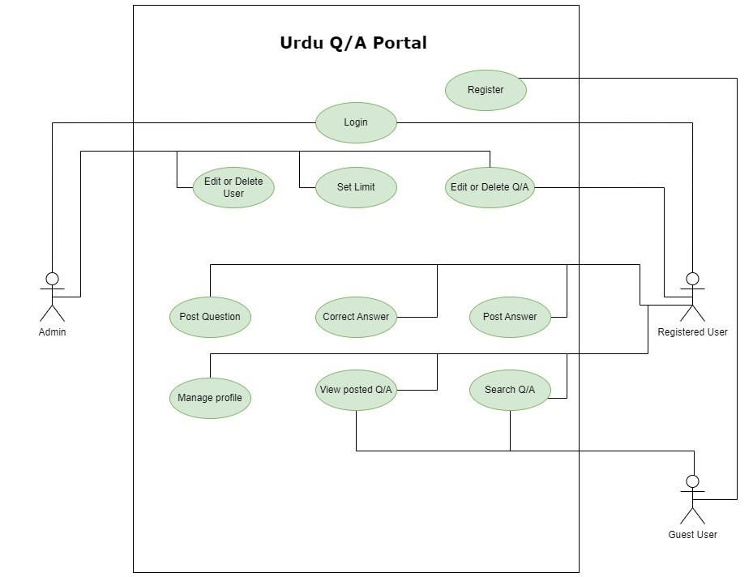

Work Plan:

